Template for preparing contributions for RNO 2024
Jimi Hendrix^{1*}, Janis Joplin² and Kurt Cobain¹
¹Department, institution, address
²Department, institution, address
*E-mail: eltapicero@hallegado.ya

- Format description
You should use this template to typeset the papers to be submitted for the Reunión Nacional de Óptica 2024 (Murcia, (2)3–5 July 2024). Brief indications on the format of the papers are given here. The abstract can be written either in Spanish or English. Once the paper is finished (maximum length is 2 pages) you should generate a PDF file, which will ultimately submitted online. The maximum size of the final PDF file is 3MB.

The text will be structured in sections. Some styles (Title, Author, Address, Email, Section and Main text) are defined to facilitate formatting every part of the text, though this template can be used, just substituting the different parts by the new ones. References to articles[1], books[2] or conference proceedings[3] will be listed at the end of the document, following the order of citation. The examples at the end of this template illustrate the required format of the reference list. Equations must be inserted in a different line, numbered on the right side of the line, placing the number between brackets.

$$∇×\vec{E}=−\frac{∂\vec{B}}{∂t}$$ | ()
The previous expression should be referenced in text as Eq. (1). You can copy and paste the previous table equation to write the next mathematical expression:

EMBED Equation.3 $∇×\vec{E}=0$ | (2)
- Figures and tables
Figures and tables are centered. “Figure caption” and “Table caption” styles are used to format the caption, which is placed immediately under the figure. See examples below. The figure and table should be referred in text as Fig. 1 and Table 1.

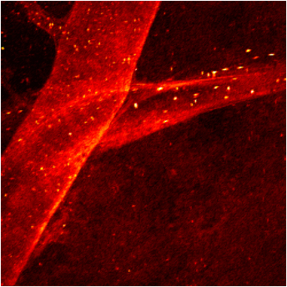
- Example of figure.

Zoom | Distance (mm) | AN
5x | 25.5 | 0.1
10x | 14.8 | 0.25
20x | 8.3 | 0.40
40x | 4.3 | 0.65
60x | 2.9 | 0.85

- List of microscope objectives.

- Conclusions
Please remember that the maximum size of the final 2-pages PDF file is 3MB.

Acknowledgments
This section is not numbered.

References

[1] A. Onestone and P. W. Giggs, “Optical properties of the Giggs photon”, Phys. Rev. 6, 430–439 (1905).
[2] P. W. Giggs and A. Onestone, Teaching Giggs photon optics (Academic Stress, New York, 2033).
[3] M. C. Intosh and S. Windows, “New trends on photonics of the Giggs photon”, in XXL Conference on optical properties of the Giggs photon (2036), vol. 1264, 454–465.

